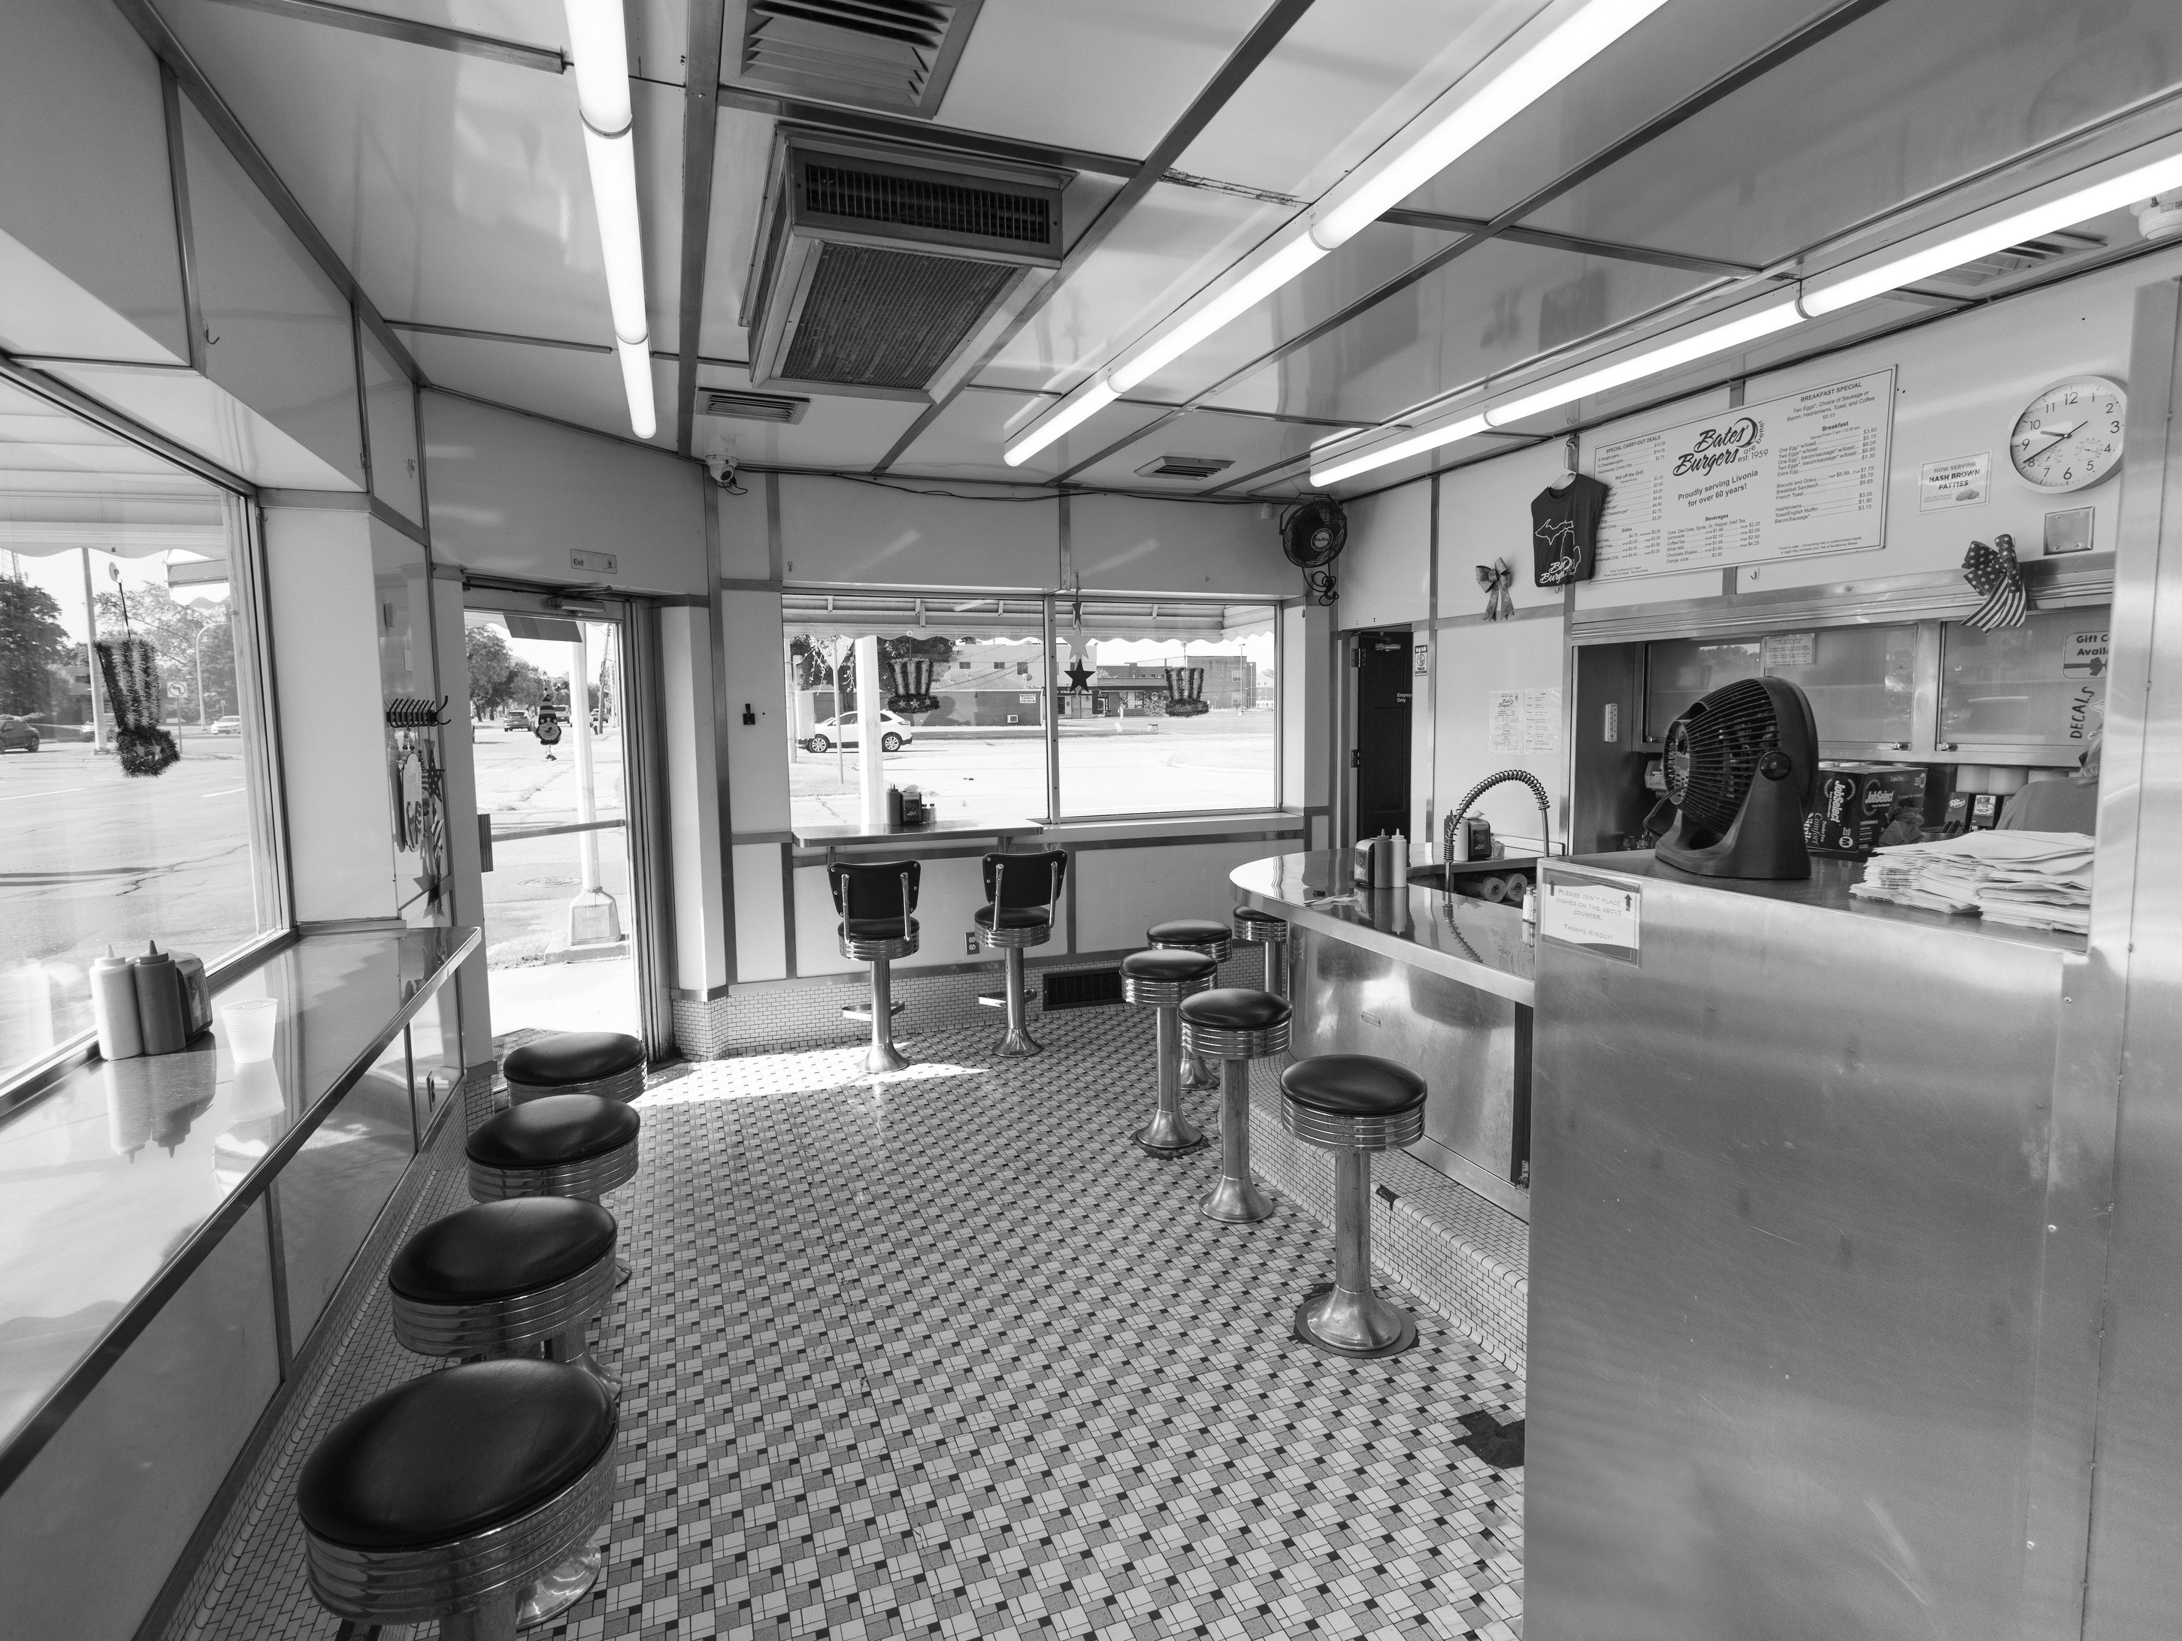
Crave Diner
CLEANING CHECKLIST

Shift Hours: | Monday to Friday (9 AM to 5 PM)

Staff: | - Name here  - Name here  - Name here  - Name here

Cleaning Checklist

DAILY CLEANING
Item | Timing | Accomplished By
Sanitize prep tables and cutting boards | Before service | Employee name here
Wipe grills, griddles & stovetops | End of service | Employee name here
Item here | Timing here | Employee name here
Item here | Timing here | Employee name here

WEEKLY CLEANING
Item | Timing | Accomplished By
Wash walk-in ﬂoors & sanitize gaskets | Monday AM | Employee name here
Scrub backsplashes, walls and oven racks | Sunday PM | Employee name here
Item here | Timing here | Employee name here
Item here | Timing here | Employee name here

Safety and Sanitation Reminders

- Use this section to highlight important reminders for the cleaning crew and staff.
- This includes the proper handling and storage of cleaning chemicals, as well as the correct disposal of waste.
- Reminder here
- Reminder here



